INTENDED USE

The Orion™ TL-3 barrier (SWM16a/b) is a high performing temporary steel barrier designed to provide work zone barrier protection to temporary construction sites and other miscellaneous roadside activities. The Orion™ steel units are attached together by removable steel pin connectors. The first and last units need to be anchored to the ground with standard (off the shelf) anchor pins. The pre-assembled nature of the barrier simplifies its transportation and deployments allowing for install rates of up to 370 m/h.

The Orion™ deployment involves placing individual units with a crane and interlocking the sections with a unique ‘twin pin’ connecting rod. Orion™ can be deployed straight or with low curvature, on either roadside or median applications.

SWM16a/b is a NCHRP 350 Test Level 3 accepted barrier

FEATURES AND SPECIFICATIONS

- Positive work zone barrier protection
- Exceptionally good vehicle control and low deflection
- Easy and fast installation (compared to concrete or plastic)
- Up to 185m can be fitted in one truck load
- Up to 370m can be deployed in one hour
- It only requires anchoring at the first and last units
- Low deflection “fully pinned” option also available
- Connects directly to the Absorb 350™ Crash Cushion
- Low cost and easily repaired after impact
- Tested and accepted to NCHRP 350 Criteria, Test Level 3 (TL-3)
- Effective Length: 12.3m (4.3m also available)
- Height: 883mm; Width: 477mm
- Weight (per unit): 896kg; Weight (per meter): 73kg
- Minimum Radius: 124m-355m
- Deflection (2000P): 1.85m
APPROVALS

FHWA Acceptance Letter: B-217.

CONTACT INFORMATION

Armorflex International LTD
www.armorflex.co.nz
Telephone: +64 9 4269174
156 Foundry Rd
Silverdale, Auckland 0932
New Zealand

ORION™ PORTABLE STEEL BARRIER TL-3
SWM16a/b |  | 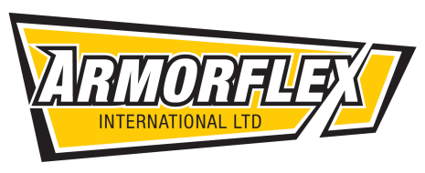
SHEET NO. | DATE
2 of 2 | 07/10/2013

